April 22, 2024

Ms. Casey Nichols
Executive Director
Texas State Board of Dental Examiners
1801 Congress, Suite 8.600
Austin, TX. 78701

Dear Ms. Nichols:

I am writing on behalf of the Texas Academy of General Dentistry (Texas AGD) in reference to proposed new rule 22 TAC §115.10, concerning the administration of local infiltration anesthesia by a dental hygienist, as well as the proposed amendments to TAC §114.5, regarding coronal polishing, which were published in the March 22, 2024, edition of the Texas Register.

The Texas AGD Board of Directors supports both rules as published.

Thank you for your consideration.

Sincerely,
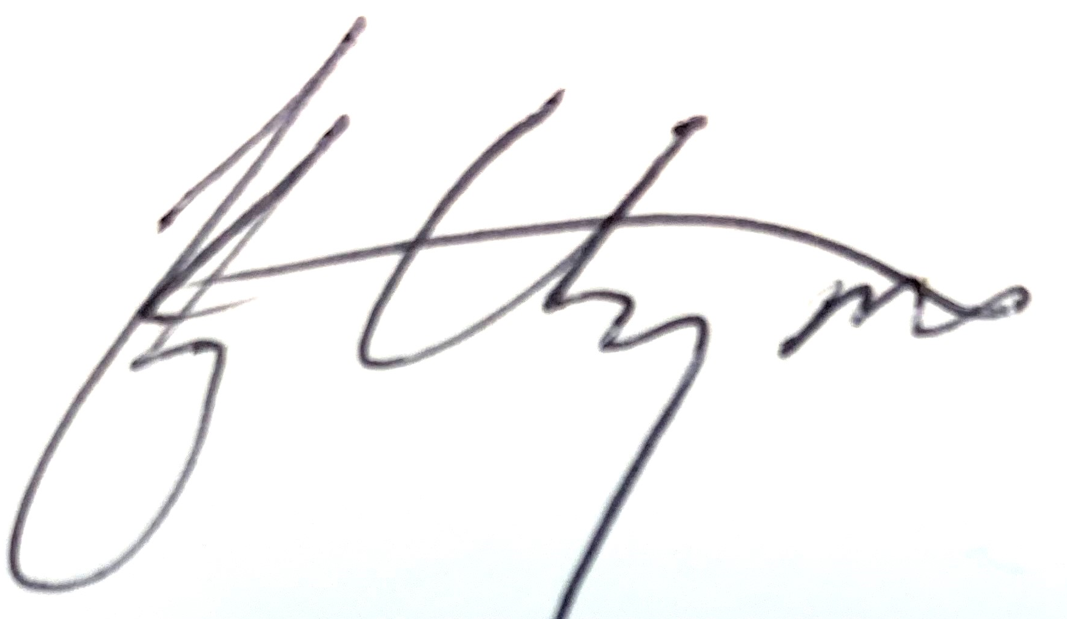
Alex Gonzalez, DDS, MAGD
President
Texas Academy of General Dentistry

